# Visit the Campus

[](https://www.tougaloo.edu/student-life)

Words and pictures give you impressions of Tougaloo, but to fully appreciate it, you need to visit us in person! We invite you to visit Tougaloo for an event or personal visit. During any of our visits or events we can make arrangements for you to eat in one of our dining facilities, attend a class or meet with professors or coaches.

Interested in bringing your school group to visit campus? Special tours can be arranged for groups of 10 or more students. We welcome this opportunity to showcase our academic programs and vibrant student community.

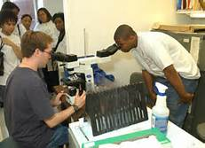 

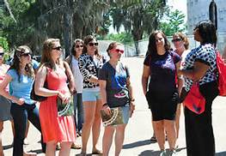

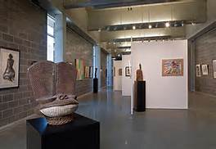

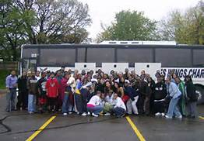

 **TOUGALOO COLLEGE**

**Department of Enrollment and Retention Management**

**Campus Tour Request Form** (*required fields)

We recommend planning your visit at least **two weeks** in advance so that we may arrange the appointments you have requested and contact you to confirm your appointment.

First Name*

|  |
| --- |
|  |

Last Name*

|  |
| --- |
|  |

Tour Group/Organization*

|  |
| --- |
|  |

Email Address*

|  |
| --- |
|  |

Mobile Number* Telephone Number*

|  |
| --- |
|  |

|  |
| --- |
|  |

Street Address

|  |
| --- |
|  |

City State Zip

|  |
| --- |
|  |

Preferred Day/Date of Visit* Alternate Day/Date of Visit* Preferred Time of Visit*

|  |
| --- |
|  |

|  |
| --- |
| a.m. / p.m. |

|  |
| --- |
|  |

|  |
| --- |
|  |

|  |
| --- |
|  |

Number of Students Number of Adults

What would you like to do during your visit?*  
Take a campus tour  Meet an Admissions Counselor  Talk to a faculty member

 Sit in on a class  Have lunch ($7.19 per person/Lunch served 11:00 a.m. – 1:30 p.m.)

 Meet with a coach Indicate sport: ⧠Basketball ⧠Baseball ⧠Tennis ⧠Volleyball ⧠Cross-Country

 Other (use comment field below)

Comments

|  |
| --- |
|  |

Email the completed Campus Tour Request to Ms. LaQuanda Fields at lfields@tougaloo.edu. If you have questions, please contact Ms. Fields at 601-977-7772.